**SPRING BOOT REST API LEARNING DOCUMENT**

Table of Contents

REST API BASICS 1

Introduction 1

URL, Resource and Sub-resource 1

SPRING BOOT AND REST API BASICS 1

# **REST API BASICS**

## Introduction

## URL, Resource and Sub-resource

## HTTP Method

## HTTP Status

# **SPRING BOOT AND REST API BASICS**

## Create Spring Boot project

<https://start.spring.io/>

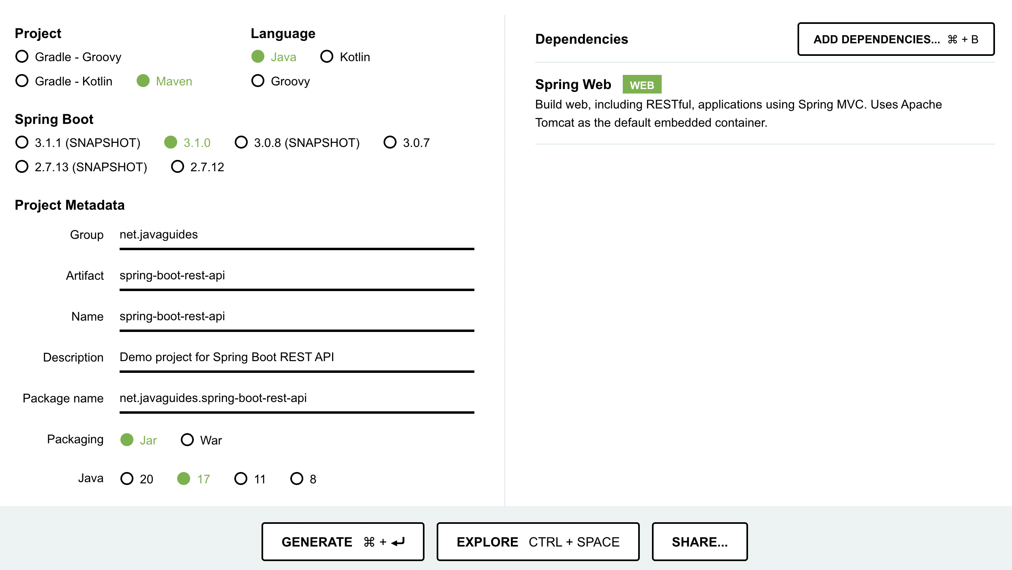

Create demo controller

The @ResponseBody annotation tells a controller that the object returned is automatically serialized into JSON and passed back into the HTTP Response object.

@RestController = @Controller + @ResponseBody